For Release November 6, 2014

NEW FAMILY OF HARDY BENCH SCALES DELIVERS PERFORMANCE WITH CHOICE OF C2 ELECTRONIC CALIBRATION

SAN DIEGO, Nov. 6, 2014---Hardy Process Solutions has announced a new family of Hardy Bench Scales designed for industrial weighing applications in industries such as food and beverage, consumer packaged goods and chemical processing.

Hardy Bench Scales are available in either stainless or carbon steel base construction, with 304 Stainless Steel platters. Customers can select from hermetically sealed, IP68/69K, C2 load cells and environmentally sealed, IP67 load cells, depending on their application. All Hardy Bench Scales come standard in 12”x12”, 18”x18”, and 24”x24” sizes, and range in capacity from 5 lbs – 1,000 lbs (2.27 kg to 454 kg). Custom sizes and capacities are available upon request.

According to Eric James, Product Manager, “Hardy Bench Scales deliver the ultimate in product configurability and customization for use in all industrial weighing applications, offering customers the ability to choose the right product at a price that fits their budget. In this family, we are offering stainless or carbon steel base construction and a choice between hermetically sealed, IP68/IP69K load cells with Hardy C2 Electronic Calibration and environmentally sealed, IP67 load cells, depending on the application.”

Hardy HI BS400 Series
The 400 Series is Hardy’s top of the line industrial bench scale. With all stainless steel construction and a hermetically sealed, IP68/IP69K, FM Hazardous approved, stainless steel Advantage® load cell, the HI BS400 is built for the heaviest wash down applications and corrosive environments. Hardy has built its C2 weight-free calibration technology into every scale, delivering the lowest total cost of ownership on the market. C2 calibration saves time during commissioning and replacement, removes personnel from processing areas, and keeps the process cleaner by eliminating the need for potentially contaminated test weights.

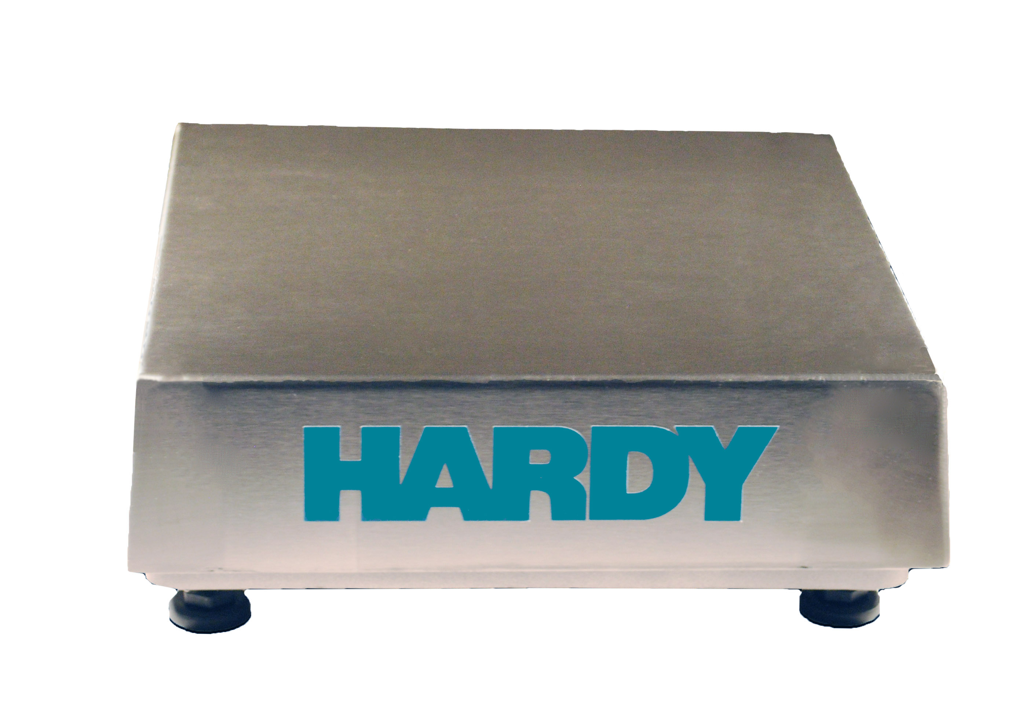
Hardy HI BS300 Series
The Hardy 300 Series is a Hardy’s lowest cost stainless steel industrial scale, built to handle light wash down and humid environments. Each bench scale is equipped with an FM approved IP67 aluminum load cell, and comes with NTEP (pending) certifications standard.

Hardy HI BS200 Series
The 200 Series is Hardy’s lowest cost industrial scale, featuring a painted carbon steel base and IP67 aluminum load cell made for use in dry and dusty environments. Each aluminum load cell is FM approved, and the HI BS200 comes with NTEP (pending) certifications standard.
For seamless integration into a manufacturing control system, attach any of the Hardy Bench Scales to a Hardy Weight Processor or Weight Controller with EtherNet/IP, Profibus-DP, Modbus, or Analog 4-20mA output. Or connect to a Hardy PAC or PLC plug-in weight module for the cleanest installation on the market.
All Hardy Scales can be paired with an optional 12” or 24” Indicator Column for instrument mounting. Hardy Bench Scales are also available with a ball-top platter to streamline roll-on, roll-off weighing applications.

Process Weighing Applications
Hardy Bench Scales are ideal for the following applications:
- Minor Ingredients or Hand-Add applications
- Small Batch Reactor Applications in Chemical/Biochemical
- Machine Filling and Dispensing
- Conveyor Scales
- Product Inspection: Check Weighing, Piece Count, Portion Control
- Shipping
About Hardy Process Solutions
Hardy Process Solutions has established itself as an industry leader in the weighing automation world by providing highly accurate precision measurements, while seamlessly integrating process weight signals into a Rockwell plant control system. At Hardy, we believe that industrial weighing solutions should be EASY to engineer and operate. We believe that simplicity delivers the LOWEST TOTAL COST to own. That’s why our solutions are EASIER to install, integrate, commission, diagnose and maintain in all four areas of the supply chain.
1. STOCK - accurate weight and level measurement/monitoring
2. MAKE - adaptable weight & rate material feed measurement/control
3. PACK - for robust rate & weight feed measurement/control
4. SHIP - off-the-shelf static and dynamic check weighing solutions

Want MORE PRODUCTIVITY at the LEAST TOTAL COST to own? Call Hardy to discover how Today! For further information, visit the Hardy Process Solutions website at www.hardysolutions.com, call 858-278-2900 or email hardyinfo@hardysolutions.com.

Press Contact: Janice Kall at 858-255-6782 or Janice.kall@hardysolutions.com

